Title
Travelling Salesperson Problem Comparison (Dynamic Programming vs Nearest Neighbor Greedy Approach)

2. Objective
To solve the Travelling Salesperson Problem (TSP) using Dynamic Programming and the Nearest Neighbor Greedy approach, compare their tour costs and computational effort, and analyze exact versus heuristic methods.

3. Problem Statement
A salesperson must visit four cities exactly once and return to the starting city while minimizing the total travel distance. The problem can be solved using Dynamic Programming (exact approach) and the Nearest Neighbor Greedy algorithm (heuristic approach). Their performance and optimality are compared.

4. Introduction
The Travelling Salesperson Problem (TSP) is one of the most important optimization problems in computer science. It aims to find the shortest possible route that visits every city exactly once and returns to the starting point.
Two approaches are considered:
- Dynamic Programming (Exact Method)
- Nearest Neighbor Greedy Algorithm (Heuristic Method)

PROGRAM:
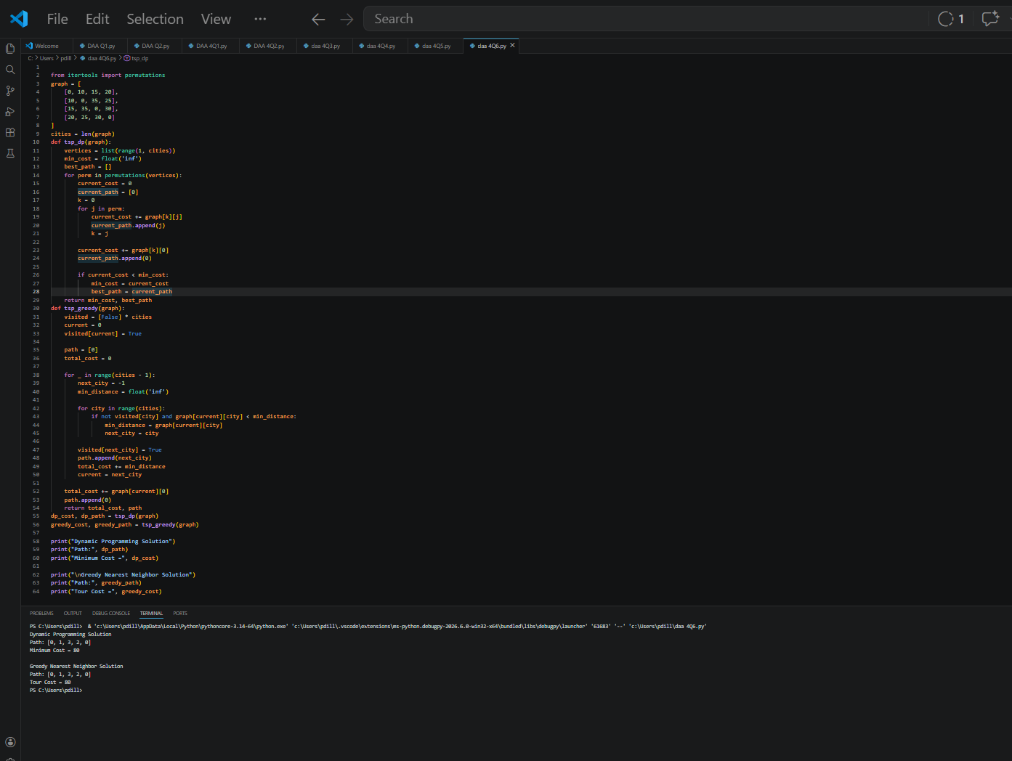
Advantages
- Fast execution.
- Simple implementation.
- Suitable for large datasets.
Time Complexity
O(n²)

5.Comparison of Results
Parameter | Dynamic Programming | Greedy Heuristic
Solution Type | Exact | Approximate
Optimal Solution | Guaranteed | Not Guaranteed
Time Complexity | O(n² × 2ⁿ) | O(n²)
Space Complexity | O(n × 2ⁿ) | O(n)
Scalability | Limited | Better

6.Computational Effort
Dynamic Programming
- Examines many subsets.
- Requires higher memory.
- Computational cost increases exponentially.
Greedy Algorithm
- Performs fewer computations.
- Requires less memory.
- Faster for larger problems.

Conclusion
Dynamic Programming guarantees the optimal tour for the Travelling Salesperson Problem but suffers from exponential complexity. The Greedy Nearest Neighbor approach provides faster solutions and better scalability but does not always produce the optimal route. The choice between exact and heuristic methods depends on the problem size and performance requirements.

References
- Thomas H. Cormen, Introduction to Algorithms.
- Data Structures and Algorithms Using Python.
- Optimization Techniques and Heuristic Algorithms.

